Exodus – Chapter Two – 23 October 2014, Anno Domini

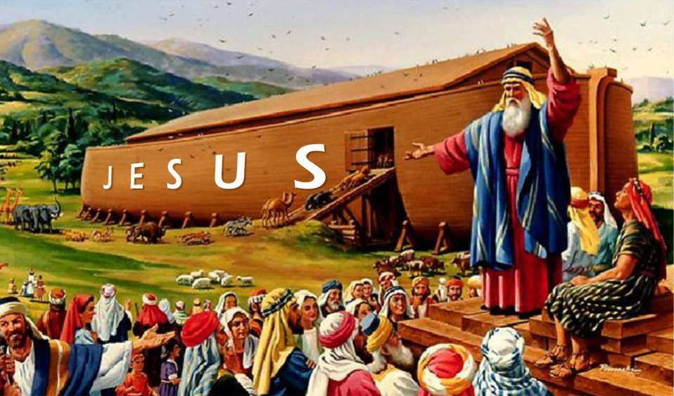

God always provides an Ark of Salvation for those who walk with Him.. He provided an Ark for Noah, He provided an Ark for Baby Moses, and He has prepared an Ark for you an me. You may ask, “What Ark of Salvation has God provided for me? Do you know the answer to that question, Friend?

The Ark of our Salvation is the LORD JESUS CHRIST. In Him we shall all rise higher and higher above the devastation coming upon the earth.

We are reminded that Pharaoh has ordered the death of every male child born of the Hebrews.

The secular power forever despises any recognition of the sovereign power of God, but it is forced, after great failures, to submit to that sovereignty.

And there went a man of the house of Levi, and took to wife a daughter of Levi. And the woman conceived, and bare a son: and when she saw him that he was a goodly child, she hid him three months. And when she could not longer hide him, she took for him an ark of bulrushes, and daubed it with slime and with pitch, and put the child therein; and she laid it in the flags by the river's brink. And his sister stood afar off, to wit what would be done to him. (Ex 2:1-4)

Moses was born a Levite. He had at least one older brother, Aaron, and an older sister, Miriam. It was perhaps Miriam that watched attentively to see what would happen to the little ark of papyrus and bulrushes in which baby Moses was placed and launched upon the banks of the Mighty Nile. You can imagine the anxiety with which this young girl watched to see what would become of her precious little brother. Love grows much stronger under adversity and it is perhaps the abject lack of adversity in our society today that has led to such a lapse in love among family and friends.

Regardless the cunning and planning of the mother, Jochebed, it is the Providence of God that will determine the fate of Moses. God has plans for Moses many years hence, and those plans will not be foiled.

And the daughter of Pharaoh came down to wash herself at the river; and her maidens walked along by the river's side; and when she saw the ark among the flags, she sent her maid to fetch it. And when she had opened it, she saw the child: and, behold, the babe wept. And she had compassion on him, and said, This is one of the Hebrews' children. (Ex 2:5-6)

According to the Hebrew scholar, Josephus, the name of the princess was Thermuthis. He also adds that the little ark was carried along by the coastal current of the Nile among the bulrushes along the shore. It is not out of character for the heart of a young heathen girl to be touched by the cry of a baby of any race. The baby was uncommonly handsome, and the princess was immediately taken in her heart for the child.

We should remember that an enemy at arms may be cruel and hateful, but there are always those in his homeland who are willing to extend mercy and love to a stranger’s baby. Thermuthis was such a princess of golden heart and compassion.

Thus far, God has allowed the mother’s hands, the eyes of the sister of Moses, and the compassion of a heathen princess to do His service in saving little Moses. His sovereign Providence is ready to go the extra mile and work wonders for Moses and his mother.

Then said his sister to Pharaoh's daughter, Shall I go and call to thee a nurse of the Hebrew women, that she may nurse the child for thee? And Pharaoh's daughter said to her, Go. And the maid went and called the child's mother. (Ex 2:7-8)

Only the wisdom and power of God could bring a baby to the household of the man who ordered its death, cause his daughter to love the child, and the mother to nurse it. Can you conceive of any more blessed result? Could we have even planned such care in our imaginations? Our God is an awesome God!

And Pharaoh's daughter said unto her, Take this child away, and nurse it for me, and I will give thee thy wages. And the woman took the child, and nursed it. And the child grew, and she brought him unto Pharaoh's daughter, and he became her son. And she called his name Moses: and she said, Because I drew him out of the water. (Ex 2:9-10)

Please note the absolute and complete provision of God in this circumstance. The mother was trying to save the life of her baby. She placed the baby in the largest river of the world. God allowed the Princess of Egypt to find the baby and to call its mother to nurse it! She even paid Jochebed to nurse her own baby. Do you see how miraculously God can turn a hopeless situation into a wondrous blessing! Moses even became a son in the royal family of Egypt. (You can’t make this stuff up, friends!)

The Princess will love Moses as her own baby. He will be raised – not in bondage with his fellow Hebrews, but in the opulence of the grandeur of Egypt - much like Joseph.

And it came to pass in those days, when Moses was grown, that he went out unto his brethren, and looked on their burdens: and he spied an Egyptian smiting an Hebrew, one of his brethren. And he looked this way and that way, and when he saw that there was no man, he slew the Egyptian, and hid him in the sand. And when he went out the second day, behold, two men of the Hebrews strove together: and he said to him that did the wrong, Wherefore smitest thou thy fellow? And he said, Who made thee a prince and a judge over us? intendest thou to kill me, as thou killedst the Egyptian? And Moses feared, and said, Surely this thing is known. (Ex 2:11-14)

Moses was somehow informed of God that the Hebrew people were his own. He was forty years of age at the time of this event. (see St. Stephens remarks in Acts 7:23)

A foremost characteristic of a man of God is his sense of justice. God is just, and all who honor Him must have a sense of justice! When Moses sees his Hebrew brethren being beaten and abused by the Egyptian taskmaster, he cannot restrain his anger!

Now when Pharaoh heard this thing, he sought to slay Moses. But Moses fled from the face of Pharaoh, and dwelt in the land of Midian: and he sat down by a well.” (Ex 2:15) Moses flees Egypt for Midian.

As we learned in Genesis, as well as the Gospels, wells of water play a great role in the life of man – both physical wells, and spiritual ones. Moses finds himself at a well of water in Midian.

Now the priest of Midian had seven daughters: and they came and drew water, and filled the troughs to water their father's flock. 17 And the shepherds came and drove them away: but Moses stood up and helped them, and watered their flock. 18 And when they came to Reuel their father, he said, How is it that ye are come so soon to day? 19 And they said, An Egyptian delivered us out of the hand of the shepherds, and also drew water enough for us, and watered the flock. 20 And he said unto his daughters, And where is he? why is it that ye have left the man? call him, that he may eat bread. (Ex 2:16-20)

If you are drawn to the drama of romance, the Bible is filled with beautiful romances.

And Moses was content to dwell with the man: and he gave Moses Zipporah his daughter. And she bare him a son, and he called his name Gershom: for he said, I have been a stranger in a strange land. (Ex 2:21-22)

And it came to pass in process of time, that the king of Egypt died: and the children of Israel sighed by reason of the bondage, and they cried, and their cry came up unto God by reason of the bondage. And God heard their groaning, and God remembered his covenant with Abraham, with Isaac, and with Jacob. And God looked upon the children of Israel, and God had respect unto them. Ex 2:23-25 (KJV)

The King James Bible is written with the beauty and grace of Shakespearean English. It is true that God heard the groaning of His people, and that He remembered His covenant with Abraham, Isaac, and Jacob; however, that does not mean that His ears were EVER stopped to their tears and groaning, or that His memory failed at any point of His promise to them. God is forever in the present – the Great I AM! He never forgets, and is never unaware of every circumstance.

Our next chapter (Three) in Exodus, is the summit of one of those Great, Lone Mountains of Scripture. In it, we read of the calling of Moses by God from without the Burning Bush that was not consumed.

It is the beginning of God’s fulfillment of His promise to Abraham, Isaac, and Jacob. It will lead to the freeing of Israel from bondage in Goshen, the baptism of an entire nation of people at once beneath the waters of the Red Sea, their forty years of wondering in the Wilderness, and their being brought to the narrow waters of Jordan Banks.

