Exodus – Go down Moses – 17 October 2014, Anno Domini
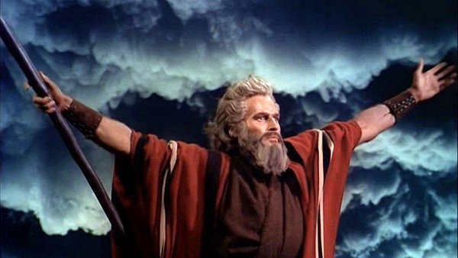
This is not actually Moses, it is Charlton Heston. If you don't know the difference, you need to read this devotion!

Go, and gather the elders of Israel together, and say unto them, The LORD God of your fathers, the God of Abraham, of Isaac, and of Jacob, appeared unto me, saying, I have surely visited you, and seen that which is done to you in Egypt: And I have said, I will bring you up out of the affliction of Egypt unto the land of the Canaanites, and the Hittites, and the Amorites, and the Perizzites, and the Hivites, and the Jebusites, unto a land flowing with milk and honey. (Ex 3:16-17)

This is the introductory lesson for the study of the Book of Exodus. As you will recall, Joseph has died and been placed in a coffin in Egypt – but not buried for his bones shall be carried back to Canaan. God will leave no part of His people, either THEN, or NOW, ‘down in Egypt – the land of sin and curse.’

Prophetically speaking, Egypt represents bondage and egregious sin. In reference to the two witnesses of the latter days, we read: “And when they shall have finished their testimony, the beast that ascendeth out of the bottomless pit shall make war against them, and shall overcome them, and kill them. And their dead bodies shall lie in the street of the great city, which spiritually is called Sodom and Egypt, where also our Lord was crucified.” (Rev 11:7-8) As we all know, Jesus was crucified in Jerusalem that this comment compares to the utter wickedness of Sodom and Egypt.

Below is a rough outline of Exodus:

- Chap 1: The slavery and oppression of the Hebrews in Egypt.
- Chap 2-3) The birth of Moses and his education in ancient Egypt, The life and calling of Moses to be the Hebrew deliverer of Israel.
- Chap 4-11) Moses and Aaron approached the Pharaoh of Egypt, the hardening of Pharaoh's heart, the plagues of Egypt;
- Chap12-13) The First Passover, The Exodus of the Israelites from Egypt
- Chap 14-15) The miracle of the parting of the Red Sea, The destruction of the Egyptian army.
- Chap 16-18) The journey to Mount Sinai, the manna, the Sabbath, water from the rock, Jethro.
- Chap 19-31) The giving of the law from God to Moses on Mount Sinai.
- Chap 32-33) The sin of the golden calf, the consequences of idolatry.
- Chap 34-40) The unbroken tables of the law written on stone, the building of the tabernacle.

Why is it important to know the Old Testament books such as Genesis, Exodus, Ruth, etc? Because, if you do not know of God’s Plan and Creation of the Universe, you cannot know His will in any other area. If you do not know of the first Passover in Egypt, you can never grasp the full meaning of the sacrifice of the Lam of God on Calvary’s brow. If you do not understand the similarities of the Book of Ruth with the Gospels of Christ, you cannot fully understand either one. The Old Testament is prelude to the New. It is filled with types and shadows of that which is to come in the New Testament. The Old Testament reveals our great need of a Redeemer from the bondage of the Law contained in it. God provides those laws as an example to us that proves we cannot be righteous. The Old Testament Church failed to “earn” salvation in the keeping of the Law; and the New Testament Church must learn from that failure.

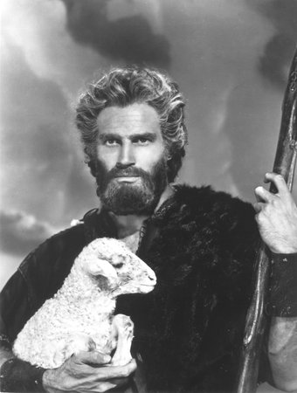
But, you may ask, is the Law of God annulled by the New Testament? By no means! The requirements of the Law were satisfied in Christ – BY THAT LAW! Loving Christ and His commandments shield us from the judgment and severity of the Law. Instead of having the Law roughly written on Tables of Stone, the Love of Christ has written them in the soft sinews of our hearts. “For this is the covenant that I will make with the house of Israel after those days, saith the Lord; I will put my laws into their mind, and write them in their hearts: and I will be to them a God, and they shall be to me a people: And they shall not teach every man his neighbour, and every man his brother, saying, Know the Lord: for all shall know me, from the least to the greatest. For I will be merciful to their unrighteousness, and their sins and their iniquities will I remember no more. In that he saith, A new covenant, he hath made the first old. Now that which decayeth and waxeth old is ready to vanish away.” (Hebrews 8:10-13) Paul states the issue even more starkly in 2 Corinthians 3:3: “Forasmuch as ye are manifestly declared to be the epistle of Christ ministered by us, written not with ink, but with the Spirit of the living God; not in tables of stone, but in fleshy tables of the heart.”

It is love that enforces the lawful intent of the soul devoted to God. Chance has nothing to do with obedience to the law. We make mistakes by oversight or careless actions, but it is the intent of the heart, motivated by a love of God and His creatures, that determine the verdict. Having accepted the sacrifice of the blood of Christ as a propitiation for our sins, the one constraining force to obedience is LOVE. Peter loved our Lord Jesus Christ enough to risk his life in the Garden at Gethsemane; but when separated from Christ, he became a cringing coward and denied his Lord thrice outside the court of the Sanhedrin. He was driven thereby to bitter tears, but Christ forgave him in his remorse and deep repentance.

So Exodus is about a delivery of God’s people from oppressive bondage in Egypt; but it is also about God’s delivery from a different kind of bondage by the crucifixion of Christ. God is the great Deliverer. But we must put our trust in Him for the benefit.

The calling of Moses (in Exodus) as God’s emissary to bring forth Israel from Egypt and into Canaan is not so different from the calling of His ministers today. Unfortunately, many of today have not encountered a “Burning Bush” experience. They are self-called, and God may not know them. It is true; too, that many lack the courage of a Moses or of an Aaron. How many so-called (CALLED) ministers of our day will stand up to the usurpations of the Federal Government’s encroachment on religious liberty and moral teaching? Indeed, we need a Moses in our day, and many Aarons.

We discover in Exodus that, regardless the iron bonds with which we may be held, God is mighty and able to Deliver us from the strongest power on earth – whether Pharaoh, Mammon, or a runaway government in collusion with the Beast of Revelations.

We will learn also that patience is required as we are traveling through the Wilderness to freedom. While Moses was on the Mountain communing with God, his people were down below in the valley cavorting with the devil! We must have a fixed compass on the Holy Ghost and steadfast in our intent to obey our God, and not our sinful natures.

Like Moses, we may die Mt. Nebo and be buried in a hidden grave; but like Moses as well, we may appear later on a Mountain with the Lord Jesus Christ. “ And after six days Jesus taketh Peter, James, and John his brother, and bringeth them up into an high mountain apart, And was transfigured before them: and his face did shine as the sun, and his raiment was white as the light. And, behold, there appeared unto them Moses and Elias talking with him.” (Matt 17:1-3)

I request your patience in this study since it is a difficult work to construct in a way that presents every part in an intensely interesting manner. But God helping us, we shall persevere through this profoundly important Book of Exodus.

It will be most helpful if you peruse the Book, chapter by chapter, as we proceed in the study.

