Coveting, the Root of All Evil – 31 October 2014, Anno Domini

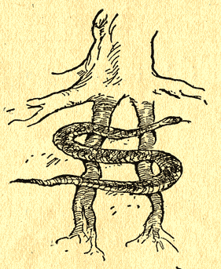

The Fifth Verse of the Third Chapter of Saint Paul’s letter to the Colossians:

5 Mortify therefore your members which are upon the earth; fornication, uncleanness, inordinate affection, evil concupiscence, and covetousness, which is idolatry: (KJV)

Paul writes a lot about becoming a New Man, that is putting aside our old selves and becoming the person God has planned for us. One of the key elements we have to put away, to get rid of, to no longer allow into our hearts and minds is covetousness.

When we think of the word covet, from which covetousness is derived, we think of the dictionary definition:

A verb meaning to yearn to possess or have something

That certainly does not seem like Ten Commandment material and it is not. The problem comes when you look into the word and its other meanings. The Greek word underlying "covetousness" is pleonexia, which means "the desire first to have more;" the constant more, the next increment is never enough. This is among the ugliest of sins because it involves idolatry as well as its effects on others.

The Greeks defined coveting as:

The insatiable desire to have what rightfully belongs to others

Notice both the insatiable part and the part about what rightfully belongs to others. They further described it as "ruthless self-seeking," the kind of attitude the arrogant and callous person has, assuming that others and their things exist for his own benefit.

It has also been described as finding morally acceptable the taking of things from others rather than earning or purchasing them.

Look back on history and see how much evil action can be laid to coveting by not only persons, but nations.

It must be understood that everything has a price that must be paid. From our eternal life which was paid for by Jesus’ one time sacrifice made for all mankind for all time to a simple meal. It has been said there is no free lunch. That is true, it is better said that everything has a price. Some things are worth paying for, some are not. Not one thing is worth coveting in the Ten Commandments sense. Take nothing that has not been paid for. If you don’t want to pay the price, don’t take it.

The inordinate desire for more money can lead to theft; the desire for more prestige, to evil ambition; the desire for more power, to tyranny; the desire for a person's body, to fornication and adultery. Paul identifies covetousness as idolatry because it puts things in the place of God. When we put things over God’s Will, we no longer worship Him, but avoid Him.

When people serve idols, they place things above God. When you covet, you are willing to set aside God for things. In the end, that never works. And, near the end it gets pretty unpleasant. We find idols easier to deal with than God. You can make an idol; God made you. If you don’t like the idol’s rules, you change the rules. Big differences there.

So what does Paul tell us to do about covetousness?

Control it?

No – Kill it. Mortify it! Make it a mort!

How does one covet and comply with the Summary of the Law?

One does not.

Become the New Man. Start today. Today, where the Finger of God touches the Line of Time from the unfathomable past to the unknowable future. We can only live today. You must become that New Man right now, for tomorrow will never come.

Well, a bit of a hyperbole; not really all, but one heck of a lot of evil can be laid at the feet of covetousness.

