Devotion on Book of Colossians (Introduction) - 7 May 2014, Anno Domini

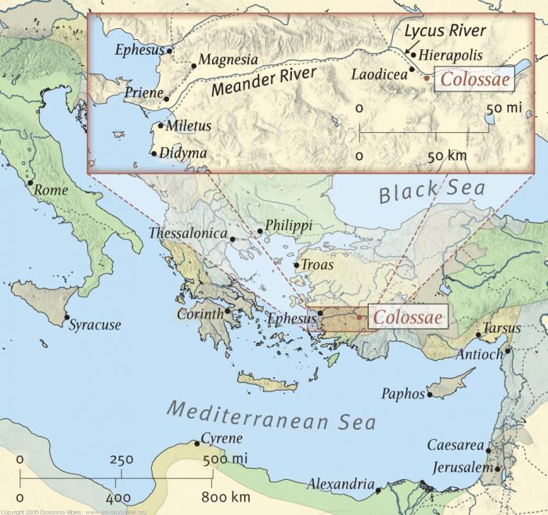

1 Paul, an apostle of Jesus Christ by the will of God, and Timotheus our brother, 2 To the saints and faithful brethren in Christ which are at Colosse: Grace be unto you, and peace, from God our Father and the Lord Jesus Christ. (Col 1:1-2)

There are commentaries that exist which claim to be conservative, evangelical, and biblically-centered; however, the first line of most of Paul’s Epistles begin with the nebulous statement that “It seems likely that Paul is the author of this Epistle, though some question his authorship.” WHAT does THAT mean, for heaven’s sake? If the first verse claims Paul as the author, that should be the end of the inquiry if one believes that God has preserved His Word inviolate.

In the Epistle to the Colossians, the letter is stipulated as being from both Paul and Timothy; however, Paul being the elder, it was his cordial manner of including Timothy, since Timothy was with him at Rome. It is very much like my sending out Christmas cards to our sons and daughters and signing them as being from Mom and Dad. I was the author of the written message, but my wife was in complete agreement with all that I wrote. Paul is the primary author, and Timothy doubtlessly concurred with his comments.

The occasion is the emergence of two separate heresies among the Colossians occurring most likely around 60 AD while Paul was imprisoned in Rome. Those heresies arose from a combination of both Greek philosophies (humanism & Gnosticism) and Judaizers (legalism). These were mingled with certain Christian truths that undermined the faith. A glass of pure water can become poisoned by a single drop of strychnine.

I can never understand why any believer would opt for a new Bible version while admitting that it was not completely faithful to the Word in all places, but was somehow presented in the “language of the street” that made it appeal to these whose taste were more of the street than of the sanctuary. There is no such thing as half-pure water. It is either pure or it is not!

There is nothing new under the sun.

Make no mistake: both of these heretical elements are present in our churches and culture of the western world today though under different disguises.

The Epistle is a revelation of the Lordship of our Lord and Savior Jesus Christ – His role as Redeemer, as King of Kings, as Lord of all Creation, and the only worthy Savior of His elect. Greek metaphysics was a major heresy that resembled, at many points, the modern Mormon faith of secret passwords and handshakes required for salvation.

The point of Colossians is to plant Christ at the very center of all that the Christian believes and holds dear. The point of every sermon should do the same. I hope that no one ever hears me preach a sermon, or read one of my devotions, that do not present Christ at the center of the whole. Our Lord’s Table with its Cross and Candles represent Christ crucified and risen, His Gospel Message is reflected in the Light of the Gospel-side candle, and the Apostolic message (Epistles) by the Epistle-side candle. These are located at the center of the sanctuary illustrating the centrality of Christ in Anglican, and other Reformed, Churches; and the pulpit and lectern are moved to the right and left sides to demonstrate that Christ – not man – is the focus of worship.

The city itself, Colossae, was a wool producing center for many centuries on the Lycus River in Ephesus. It suffered periodic devastation from volcanoes, and dwindled to almost nothing (according to Strabo) when the Romans built their major East-West highway, Via Ignatia, bypassing Colossae. Colossae was located approximately ten miles from that lukewarm city of Laodicea.

There have been great and inspiring volumes written on the Epistle to the Colossians – some constituting more than one thousand pages, so forgive me if I cannot capture a more complete explanation for all that this Epistle is saying in a devotional format. I will do my best to concisely state some of the leading points of the Epistle that will, hopefully, whet the Reader’s appetite for a more comprehensive study of its truths and beauty.

You will note in the opening verse that Paul declares himself an apostle of Jesus Christ, not by his own choosing, but by the Will of God. If a minister chooses the ministry, rather than being called by God, he is no minister at all. The letter is addressed, not only to the saints and faithful brethren in Christ at Colossae, but also to the saints and brethren of our own day. Paul concludes with the comment that indicates that all grace, and all true peace, come from God the Father, and God, the Son – Jesus Christ.

I have deemed a condensed outline to be of benefit to both the Reader and the scribe in developing an insight as to the overall body of the Epistle. Though I will attempt to rely upon all points of this outline, I may venture beyond its scope if I feel such would add to our understanding of its commentary. My outlined approach to the Epistle will be as follows:

CHAPTER 1:
The Deity of the Lord Jesus Christ and His Preeminence
- Our thankfulness for His Preeminence
- Our understanding, or theology, of His Preeminence

CHAPTER 2:
Satan’s Counterfeit and Nature of Perversions for which we must be mindful
- Flattery and enticing words
- Human Philosophy
- Vanity and its deceit
- Traditions of man
- Legalism
- Self-abasement
- Worship of Saints and Angels
- Visions and false dreams (such as round trips to Heaven or Hell)
- Man-made laws and rules

CHAPTER 3 & 4:
The Duty and Work of the Saints of God
- With respect to the Son of God (3:1-4)
- With respect to the Word of God (3:16)
- With respect to the WORK of God (3:17)
- With respect to the PEACE of God (3:15)
- With respect to our communion in talk and prayer with God (4:2-4)
- With respect to our living and expressed testimony FOR God (4:5,6)

We will begin our devotions on this Epistle in earnest on the next writing. It may be of great benefit to study this Epistle to the Colossians ahead so that you may get a better grasp of it and, by your reading, fill in the holes of understanding that I may leave unfilled in my devotional writing on the subject.

