Devotion for Wednesday after the Fourth Sunday in Lent - The Poor Widow's Mite - 9 March 2016 Anno Domini

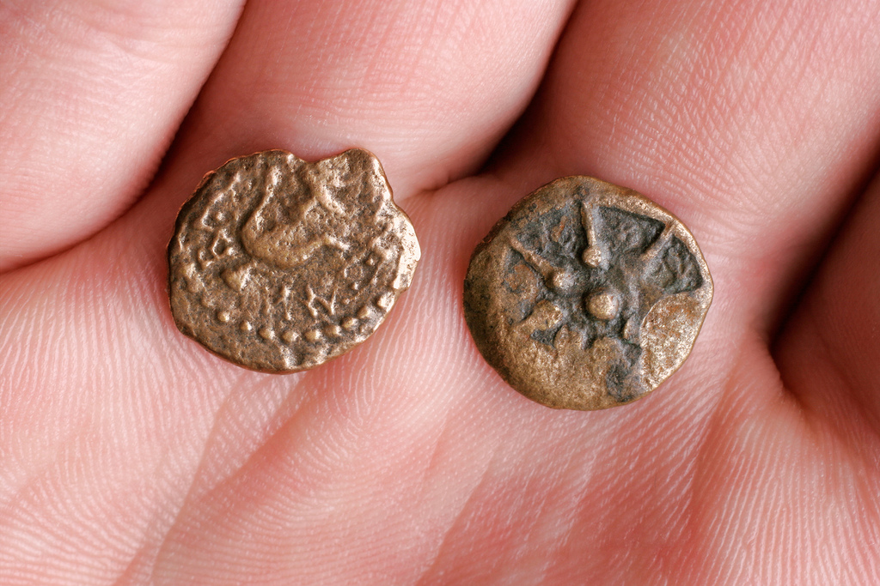

38 And he said unto them in his doctrine, Beware of the scribes, which love to go in long clothing, and love salutations in the marketplaces, 39 And the chief seats in the synagogues, and the uppermost rooms at feasts: 40 Which devour widows' houses, and for a pretence make long prayers: these shall receive greater damnation.
41 And Jesus sat over against the treasury, and beheld how the people cast money into the treasury: and many that were rich cast in much. 42 And there came a certain poor widow, and she threw in two mites, which make a farthing. 43 And he called unto him his disciples, and saith unto them, Verily I say unto you, That this poor widow hath cast more in, than all they which have cast into the treasury: 44 For all they did cast in of their abundance; but she of her want did cast in all that she had, even all her living. (Mark 12:38-44)

Today's text continues a pointed approach of our Lord to the "root of all evil." That root is not money itself, but the "LOVE" of money above all else. That was the one shortcoming of the rich young ruler who came to Jesus seeking what he might 'DO' to obtain eternal life. In the end, his wealth was his god which he could not forsake. After cleansing the Temple and turning over the tables of the money-changers, the Jewish rulers saw a clear and present threat to their luxurious lifestyle; so they undertook to find some means of destroying Jesus. The Jewish scoundrels attempt to catch Jesus off-guard by using tribute to Caesar as a snare - one which encompassed their own neck and not that of Jesus.

Now Jesus addresses the luxuriant attire of the religious leaders who dress in opulent apparel. The Lord presents, in the most concise and meaningful manner, great principles on proper clerical attire, and the improper: presumptuousness, love of filthy lucre, and giving out of our need and resources. The fewer words employed in covering a topic completely is the characteristic of a great Author, and Christ is the greatest of Authors as the Living Word Itself! The Master of the Word weaves profound principles into a tiny space and makes their beauty so stark that even secular writers and speakers employ His artistic Word Art in their public and private expressions – does the widow’s mite ring a bell? This phrase is heard from the neighborhood pawnshop to the front benches of Wall Street, and often used by men who have no idea of the original Author of it.

38 And he said unto them in his doctrine, Beware of the scribes, which love to go in long clothing, and love salutations in the marketplaces. His doctrine is unadulterated Truth, and He speaks only Truth. Christ issues an important warning to us – BEWARE! Who are the Scribes? The Mishnah presents them as pre-rabbinic teachers with authority, as well as copyists and teachers. They were also considered to be lawyers since they were so familiar with the Law of Moses (having copied and transcribed it from start to finish). But they misapplied the Word, having grown prideful of their station, and even turned the meaning of the Word of God upon its head in order to achieve their own agendas. This is why Jesus issues this stark warning to us today! Today, the scribes are those who would re-interpret Holy Scripture, adding here a different meaning, and taking away there, the very Words of God in their delusional pride. We find this fact vividly demonstrated in the rendering of new Bible versions that contain SOME of the Word of God, but add poison to parts so that the whole is unwholesome. The long garments to which Christ refers are not the simple vestments of the Temple or of those of the biblical priest – they are garments of gold-embroidered and costly fabric, loud and elaborate in design, and made to attract attention to their high station.

The so-called miters and elaborately decorated peacock robes of the Roman tradition in Anglican churches today reflect, I believe, the very robes to which Christ refers. Such men desire the acclaim and adulation of the people and do not, in the least sense, consider themselves to be the servant ministers of the people. See the counsel of Christ on prayer: And when thou prayest, thou shalt not be as the hypocrites are: for they love to pray standing in the synagogues and in the corners of the streets, that they may be seen of men. Verily I say unto you, They have their reward. But thou, when thou prayest, enter into thy closet, and when thou hast shut thy door, pray to thy Father which is in secret; and thy Father which seeth in secret shall reward thee openly. But when ye pray, use not vain repetitions, as the heathen do: for they think that they shall be heard for their much speaking. Be not ye therefore like unto them: for your Father knoweth what things ye have need of, before ye ask him. (Matt 6:5-8)

39 And the chief seats in the synagogues, and the uppermost rooms at feasts." How often do we witness today the best tables and china at church fellowships being reserved for the pastor and other clerics? High honor is the goal, but would it not be far wiser and sincere to accept the lowly station that Christ took at His Supper? Have we forgotten that we are servants and not masters?

40 Which devour widows' houses, and for pretense make long prayers: these shall receive greater damnation". It is not coincidental that Christ mentions this characteristic of the Scribes. He is about to impart a noteworthy principle on the law of giving. As He speaks, He is aware that a widow is fighting her way through the crowd to the treasury where she will deposit her fortune in the horn of the Temple. The timing of Christ is always perfect! Who today devours widows’ houses? Have you tuned in to Benny Hinn, Steve Crouch, Joel Ostten, or other notorious money grubbers lately on TV? What of churches that impose allocation on families in order to support the dreams of the pastor and others to make their church into a Taj Mahal?

The modern church characterizes the character of the Scribes of Jesus’ day more than the humble Church of Smyrna to which Christ refers in Revelation 2:8-10 And unto the angel of the church in Smyrna write; These things saith the first and the last, which was dead, and is alive; I know thy works, and tribulation, and poverty, (but thou art rich) and I know the blasphemy of them which say they are Jews, and are not, but are the synagogue of Satan. Fear none of those things which thou shalt suffer: behold, the devil shall cast some of you into prison, that ye may be tried; and ye shall have tribulation ten days: be thou faithful unto death, and I will give thee a crown of life.

41 And Jesus sat over against the treasury, and beheld how the people cast money into the treasury: and many that were rich cast in much. You will observe Christ not only observed HOW MUCH the people were giving, but more importantly in the MANNER & SPIRIT they gave. It is the condition of the heart in giving that makes all the difference! We all are rich in some way or another. We may be blessed with a successful profession or business, or we may be poor but have an abundance of time on our hands that could be devoted to helping some poor, fainting sinner. Our time is definitely a resource from which we should tithe and offer! What is a gold coin to a man who has millions? It may be far more than the yearly earnings of a poor widow, but to the rich man, it is a mere gesture of giving. He will suffer no less opulence at his evening meal, nor be harried by creditors to repay outstanding debts. But what of the poor widow who toils at humble Labors day in, and day out, to provide a simple and humble meal for herself at the day’s end. She may find it difficult to earn enough to pay her rent, or her heating bill, yet she gives to God – not a tenth – but ALL that she has in treasure.

42 And there came a certain poor widow, and she threw in two mites, which make a farthing. The widow arrives just at the moment of the Lord’s expectation. His previous remarks have paved the way for her debut. The Lord is watching the wealthy as well as the poor widow. He is watching to see how you and I share out of our blessings as well. He takes an interest in how we are stewards of His blessings that He has given to us. What are two mites compared to the large gold coins cast into the horn by the wealthy? Some may even have been ashamed to cast in so little after hearing the ringing sound of the large and valuable offerings of the wealthy. But this widow is not giving to attract attention to her generosity – she is giving out of her penury and need. She is unashamed for she has no reason to be ashamed – she has given ALL! Though it is not truly relevant to what the widow actually gave, I found an illustration that is interesting: “It is estimated that if the widow’s mite had been deposited at the “First National Bank, Jerusalem” to draw four percent interest semi-annually, the fund today would total $4,800,000,000,000,000,000,000. If a bank on earth could multiply the widow’s mite to such an astronomical figure, think what treasures this dedicated woman will have in heaven where “moth and rust doth not corrupt.” (Bibleteachingnotes.com) Interesting to note that this sum amount to more monetary cash than in circulation throughout the world today. It is Heaven's ransom.

The fact is, the AMOUNT is not the essential thing – it is the HEART of the widow in giving that is important here.

43 And he called unto him his disciples, and saith unto them, Verily I say unto you, That this poor widow hath cast more in, than all they which have cast into the treasury. Had the others cast in mansions and wagons of golden talents, it would not have risen to the level of this poor widow for she gave all. Are we not called to give our ALL for Christ? Should not our finances reflect our strong commitment to Him? The important thing is not what we give in the church offering while all eyes are watching, but that which is given unseen and unsung. The Word of God is the best measure of counsel we can have. See how Christ frames the issue of giving: Take heed that ye do not your alms before men, to be seen of them: otherwise ye have no reward of your Father which is in heaven. Therefore when thou doest thine alms, do not sound a trumpet before thee, as the hypocrites do in the synagogues and in the streets, that they may have glory of men. Verily I say unto you, They have their reward. But when thou doest alms, let not thy left hand know what thy right hand doeth: That thine alms may be in secret: and thy Father which seeth in secret himself shall reward thee openly. (Matt 6:1-4)

