Devotion for Thursday after the Third Sunday in Lent - The Unfruitful Fig Tree - 3 March 2016, Anno Domini

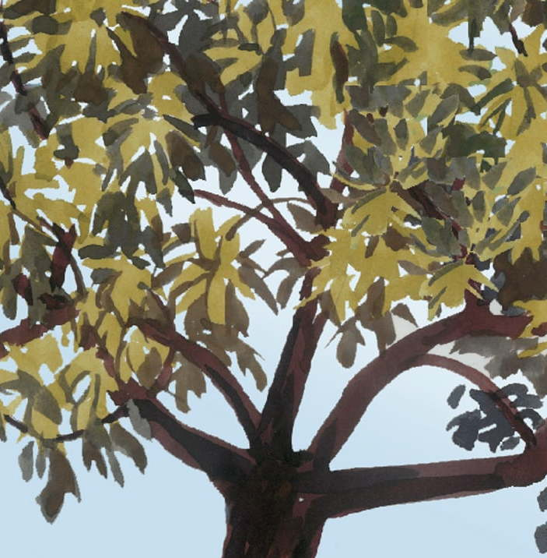

12 And on the morrow, when they were come from Bethany, he was hungry: 13 And seeing a fig tree afar off having leaves, he came, if haply he might find any thing thereon: and when he came to it, he found nothing but leaves; for the time of figs was not yet. 14 And Jesus answered and said unto it, No man eat fruit of thee hereafter for ever. And his disciples heard it. 15 And they come to Jerusalem: and Jesus went into the temple, and began to cast out them that sold and bought in the temple, and overthrew the tables of the moneychangers, and the seats of them that sold doves; 16 And would not suffer that any man should carry any vessel through the temple. 17 And he taught, saying unto them, Is it not written, My house shall be called of all nations the house of prayer? but ye have made it a den of thieves. 18 And the scribes and chief priests heard it, and sought how they might destroy him: for they feared him, because all the people was astonished at his doctrine. 19 And when even was come, he went out of the city. 20 And in the morning, as they passed by, they saw the fig tree dried up from the roots. 21 And Peter calling to remembrance saith unto him, Master, behold, the fig tree which thou cursedst is withered away. 22 And Jesus answering saith unto them, Have faith in God. 23 For verily I say unto you, That whosoever shall say unto this mountain, Be thou removed, and be thou cast into the sea; and shall not doubt in his heart, but shall believe that those things which he saith shall come to pass; he shall have whatsoever he saith. 24 Therefore I say unto you, What things soever ye desire, when ye pray, believe that ye receive them, and ye shall have them. 25 And when ye stand praying, forgive, if ye have ought against any: that your Father also which is in heaven may forgive you your trespasses. 26 But if ye do not forgive, neither will your Father which is in heaven forgive your trespasses. (Mark 11:12-26)

Jesus said to Peter in our text today, "Have Faith in God!" This is one of those very simple principles that requires a very profound application. If we are One in Christ, and Christ is One in the Father, then we are also One with the Father, Son, and Holy Ghost. Our Faith must reflect that assurance we have in God of answered prayer. Do men have a true faith today? It is certain that most do not, but what is much more appalling is the fact that most of the clergy as well have little or no faith. "Then why do they preach?" you may ask. I believe it is because many chose preaching as a profession out of a vain desire for power, prestige, and, of course, every morsel of grain they can glean from the threshing floor of the Church. The salient point here is that most preachers chose the profession, but were not chosen by God for it. Hear our Lord's counsel: "Ye have not chosen me, but I have chosen you, and ordained you, that ye should go and bring forth fruit, and that your fruit should remain: that whatsoever ye shall ask of the Father in my name, he may give it you." (John 15:16)

The matter of FAITH underlies this entire passage. Faith is evidenced by good works and love; by purity of worship with nothing of the world mixed in. The very beginning two verses set the meaning of the passages that follow. "And on the morrow, when they were come from Bethany, he was hungry: And seeing a fig tree afar off having leaves, he came, if haply he might find any thing thereon: and when he came to it, he found nothing but leaves; for the time of figs was not yet."

Lesson of the Fig Tree
Jesus is hungry today, as then, to find faith in those who call upon His Name and are called by it. Jesus sees the fig tree afar off, just as He sees those who claim faith but are devoid of it, afar off. The tree should be expected to have an abundance of fruit. Why? Because it is covered in green leaves! But isn't it possible that the figs could come after the leaves are matured? No, it is not possible since figs appear either BEFORE, or simultaneously, with the leaves. The tree is healthy and has rich foliage - but no fruit. This describes the faith-claiming Christian today whose vocabulary is full of words describing their great faith, but the fruits that should attend faith is missing. The churches today are filled with many who appear as Christian but are simply covered with the green leaves of false profession. Miters and fine robes adorn clergy who possess not the slightest elementary faith of a professing Christian. The false signs of faith claimed as "gifts of the Spirit" are no different from the leaves of the fig tree that bears no fruit.

What happens to those of false profession who bear no fruit? They wither and die - even more dead than the doornail that they were before they even adorned themselves with the leaves of false profession. "And Jesus answered and said unto it, No man eat fruit of thee hereafter for ever. And his disciples heard it..... And when even was come, he went out of the city. And in the morning, as they passed by, they saw the fig tree dried up from the roots. And Peter calling to remembrance saith unto him, Master, behold, the fig tree which thou cursedst is withered away." Thus, our Lord commands Peter to "Have Faith in God!" because faith begets fruit and works worthy of the Master. Hear how the 'Hall of Faith' given in Hebrews describes faith: "Now faith is the substance of things hoped for, the evidence of things not seen. For by it the elders obtained a good report. Through faith we understand that the worlds were framed by the word of God, so that things which are seen were not made of things which do appear. By faith Abel offered unto God a more excellent sacrifice than Cain, by which he obtained witness that he was righteous, God testifying of his gifts: and by it he being dead yet speaketh." (Heb 11:1-4)

Cleansing the Temple
The bright green branches of our contrived faith must undergo a house-cleaning. We need to rid our hearts of all that is contrary to the testimony of a convicted Christian - pride, arrogance, greed, lust, etc. If we are going to appear faithful, we must bear the fruits of faith and more than the mere appearance of it. Even the outer courts of our hearts must reflect that faith and love of Christ.

"And they come to Jerusalem: and Jesus went into the temple, and began to cast out them that sold and bought in the temple, and overthrew the tables of the moneychangers, and the seats of them that sold doves; And would not suffer that any man should carry any vessel through the temple. And he taught, saying unto them, Is it not written, My house shall be called of all nations the house of prayer? but ye have made it a den of thieves." Make no mistake - this was not the Temple proper (Holy Place and Holiest of Holies). This was the outer court referred to as the Court of the Gentiles. The Jewish leaders allowed sacrificial animals to be sold there as well as other commercial endeavors. Some biblical scholars believe this was deliberate to demonstrate their disdain for the Gentile peoples. But every corner and inch of the House of God is Holy. There are no compartments for lesser men and women of faith. What of churches that have frequent 'Yard Sales' and 'Car Washes' raising money. This is an admission that either the offerings of the people are insufficient to maintain the House of Worship, or that there are supposed needs that exceed the expedient of worship (filthy lucre comes to mind).

Jesus cleansed the House of God of the riff raff and slimy, greedy peddlers from the Holy Ground of the Temple. Will His approach be different in dealing with the jaded mansions of our day that pose as churches whose pastor and staff are made wealthy on the backs of many widows? Perhaps there is a reason that most modern and corrupted versions of the Bible omit this verse from Matthew: "Woe unto you, scribes and Pharisees, hypocrites! for ye devour widows' houses, and for a pretence make long prayer: therefore ye shall receive the greater damnation." (Matt 23:14)

How did the religious leaders react to the cleansing of the temple?
"And the scribes and chief priests heard it, and sought how they might destroy him: for they feared him, because all the people was astonished at his doctrine." Certainly, they considered how they might destroy Jesus. Do not doubt it - they KNEW who He was, but placed their power, prestige, and lifestyle ahead of the Son of God. Many today place a higher premium on social concerns and public opinion ahead of what is just and right in both religion and politics.
Jesus began His lesson with the leave-endowed fig tree. There were other trees there with leaves, but they did not presume to bear figs - only the fig tree did so. Perhaps those other trees with leaves and no fruit represented the Gentiles who would surely bear fruit when watered with the mercies and salvation of our Lord.

This mountain
" For verily I say unto you, That whosoever shall say unto this mountain, Be thou removed, and be thou cast into the sea; and shall not doubt in his heart, but shall believe that those things which he saith shall come to pass; he shall have whatsoever he saith." Our Lord began this engagement with a lesson on Fig Trees, and now ends with a reference to a mountain - but WHICH mountain? " this mountain" - that is the Mount upon which the Temple is constructed. This the apostles did accomplish when the Temple was set aside due to the doing away of Temple sacrifices when Christ became our Passover Sacrifice. Perhaps the mountainous temples of vain-glory we see in churches today may also suffer the same fate at His Coming.

Even so, come, Lord Jesus. (Rev. 22:20)

