Devotion for Lent - The Hope of Christ - 12 February 2016, Anno Domini

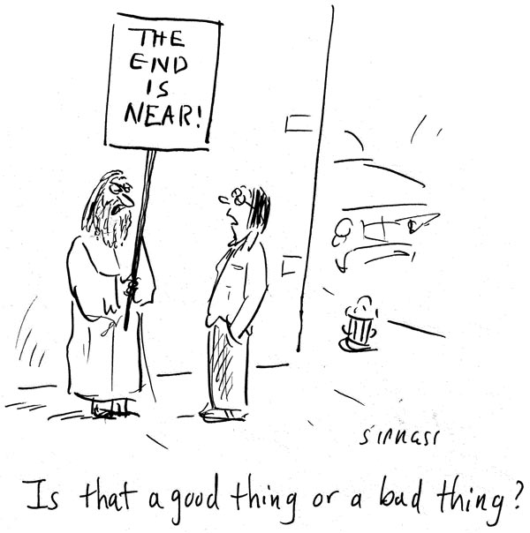

I am the resurrection, and the life: he that believeth in me, though he were dead, yet shall he live: And whosoever liveth and believeth in me shall never die. Believest thou this? (John 11:25-26)

I am the way, the truth, and the life: no man cometh unto the Father, but by me. (John 14:6)

The soul of man is born with an expectation of eternity in his heart. He cannot imagine a future time in which he does not exist; and he cannot imagine a time in the past when he did not exist. In fact, every soul has existed as long as the earth itself and even before, for we all have existed in the Mind of God from Eternity Past. He KNEW us before we were conceived in our mother's womb, and His acquaintance with us never ends. Can you imagine what it will be like for you on the third day after your own death? Is it a matter of great concern? Of course it is if you have not made provision for the safe deposit and keeping of your soul in the Bosom of God our Father.

I once read an illustration of the captain of a great luxury liner, sailing near the center of the Pacific Ocean, who invited his principal guests into the captain's diner and informed them of a grave decision he had made. The captain announced, "There is plenty of food on board. Life will proceed precisely as it has these past days at sea. Nothing will be omitted. Meals will be served, the orchestra will play at the nightly dances, there will be concerts and games; but I have decided not to continue to our port of destination. We will simply cruise about the wide Pacific in a great circle until our fuel is exhausted, then I shall sink this vessel." Please give this situation some deep thought in considering yourself a passenger aboard that vessel. Suddenly, the material things of this world hold no allurement, do they? Suddenly, sensual pleasures and desires will hold no man in their grasp. The deep yearnings and wonder of our hearts turn to concerns for our eternal souls - a concern which we should have taken into account much sooner; for the earth itself is that ship which is going to sink at the discretion and timing of its Captain.

Our Lord Jesus Christ knew His ultimate earthly ministry would end by His being nailed to the cross and cruelly ridiculed; yet He never faltered in His loving compassion, teaching, and miraculous works. How is that possible? It is because our Lord Jesus Christ knew His Father, and He knew His Father would never allow His only Begotten Son to suffer corruption. Because thou wilt not leave my soul in hell, neither wilt thou suffer thine Holy One to see corruption. Thou hast made known to me the ways of life; thou shalt make me full of joy with thy countenance. (Acts 2:27-28) You may say, "Well, that was easy for Christ because His Father had 'made known to Him the ways of life - that He would rise from the dead.” Good point, friend, but has not God the Father made the same promise in the leading text of today's devotion that you, too, who believe shall never die? I am the resurrection, and the life: he that believeth in me, though he were dead, yet shall he live: 26 And whosoever liveth and believeth in me shall never die. Believest thou this? Well, DO YOU?

If so, unlike the passengers of an ill-fated sea vessel, we have HOPE - the HOPE of the Resurrection made sure by our Lord Jesus Christ! What holds us back? Perhaps it is the senseless notion that this earthly life will never end and, even if it does, we will simply enter a timeless void of nothingness. That may be the popular belief taught in Evolution classes on college campuses, but I am sure you have been as amazed as I have been at the lack of common sense and logic being taught today on college campuses. Every soul has a port of destiny - either to be with our Lord Jesus Christ, or to be with all of the lost sinners and egregious evil doers of the world in Hell - FOREVER! So our preparation at this moment for our souls is of ultimate importance to us.

A lady once approached Ralph Waldo Emerson with the dismal news that "This world is coming to an end!" To her shock, Emerson responded, "That's alright. I can get along without it." All who know and cherish Christ can "Get along without it." But if you do not claim Christ as Lord and Savior, to what depths will your soul sink when the world is no more?

I am the resurrection, and the life: he that believeth in me, though he were dead, yet shall he live.

