Devotion for Saturday after the Fourth Sunday in Lent - The Fig Tree Prefigures the End - 12 March 2016, Anno Domini

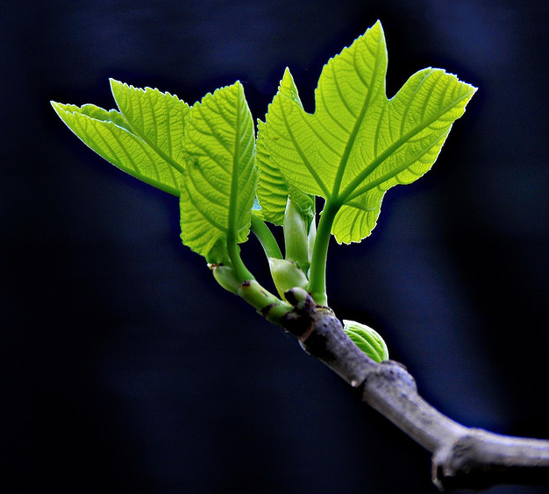

24 But in those days, after that tribulation, the sun shall be darkened, and the moon shall not give her light, 25 And the stars of heaven shall fall, and the powers that are in heaven shall be shaken. 26 And then shall they see the Son of man coming in the clouds with great power and glory. 27 And then shall he send his angels, and shall gather together his elect from the four winds, from the uttermost part of the earth to the uttermost part of heaven. 28 Now learn a parable of the fig tree; When her branch is yet tender, and putteth forth leaves, ye know that summer is near: 29 So ye in like manner, when ye shall see these things come to pass, know that it is nigh, even at the doors. 30 Verily I say unto you, that this generation shall not pass, till all these things be done. 31 Heaven and earth shall pass away: but my words shall not pass away. 32 But of that day and that hour knoweth no man, no, not the angels which are in heaven, neither the Son, but the Father. 33 Take ye heed, watch and pray: for ye know not when the time is. 34 For the Son of man is as a man taking a far journey, who left his house, and gave authority to his servants, and to every man his work, and commanded the porter to watch. 35 Watch ye therefore: for ye know not when the master of the house cometh, at even, or at midnight, or at the cockcrowing, or in the morning: 36 Lest coming suddenly he find you sleeping. 37 And what I say unto you I say unto all, Watch. (Mark 13:24-37)

The text is comprised of two parts - the first tells of the coming End Time; the second is a parable of the fig tree.

The direction the text takes today proves that the LORD is speaking - not only of the impending ruin of Jerusalem - but of the end of this present world itself. There are far more lessons of great import than can be covered in a short devotion, so the reader is encouraged to study deeply these words of our Lord. Any word of the Lord is of profound gravity but especially grave are His words of warning. The keyword to today's lesson is the very last in the text - WATCH! Which would you prefer as a watchman on the wall during a threat of impending attack - an eagle-eyed fellow who can see with great clarity over great distances, but frequently falls asleep without warning; or a steady fellow of average sight who constantly watches for any sign of enemy deployments? The lesson in that keyword is that we watch daily for the coming of Christ without spending untold efforts in the vain pursuit to pin down the exact hour of His coming.

24 But in those days, after that tribulation, the sun shall be darkened, and the moon shall not give her light, There are more tribulations than one that confronts the Christian. To those whose blessed loved sons and daughters are dying under the heartless scourge of Islam in the Levant of Syria and Iraq today are not mindful of WHICH tribulation they suffer, for the present one is enough to cause a sea of tears to flow. There are succeeding tribulations, but there looms a tribulation ahead that dwarfs all others. What is it that shall darken the sun and moon?

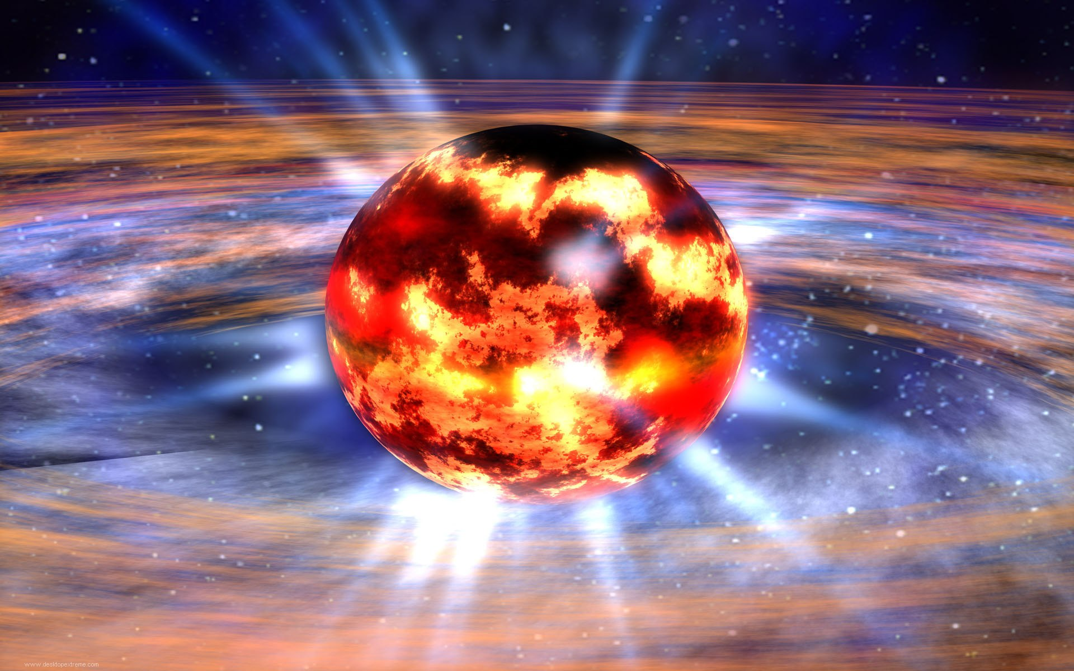
NOTE: Scientist estimate the fusion process in the sun of converting hydrogen to helium has reached a point of 50% conversion - a point at which the general historical data suggests that the star (sun) may begin to generate a rapidly expanding fireball that could extend millions of miles into space (a super Nova). It could melt with fervent heat all elements on earth. But the day of the Lord will come as a thief in the night; in the which the heavens shall pass away with a great noise, and the elements shall melt with fervent heat, the earth also and the works that are therein shall be burned up. (2 Peter 3:10) Following such an apocalyptic event, the star (sun) would collapse back into itself forming a black hole of intense gravitation pull. I do not know exactly how the Lord may bring these events to bear, but it seems that He may already programmed the DNA of the Universe to bring about His Will and Prophecy. At any rate, it is not my role, or yours, to second guess the Lord. We need only take Him at His Word.

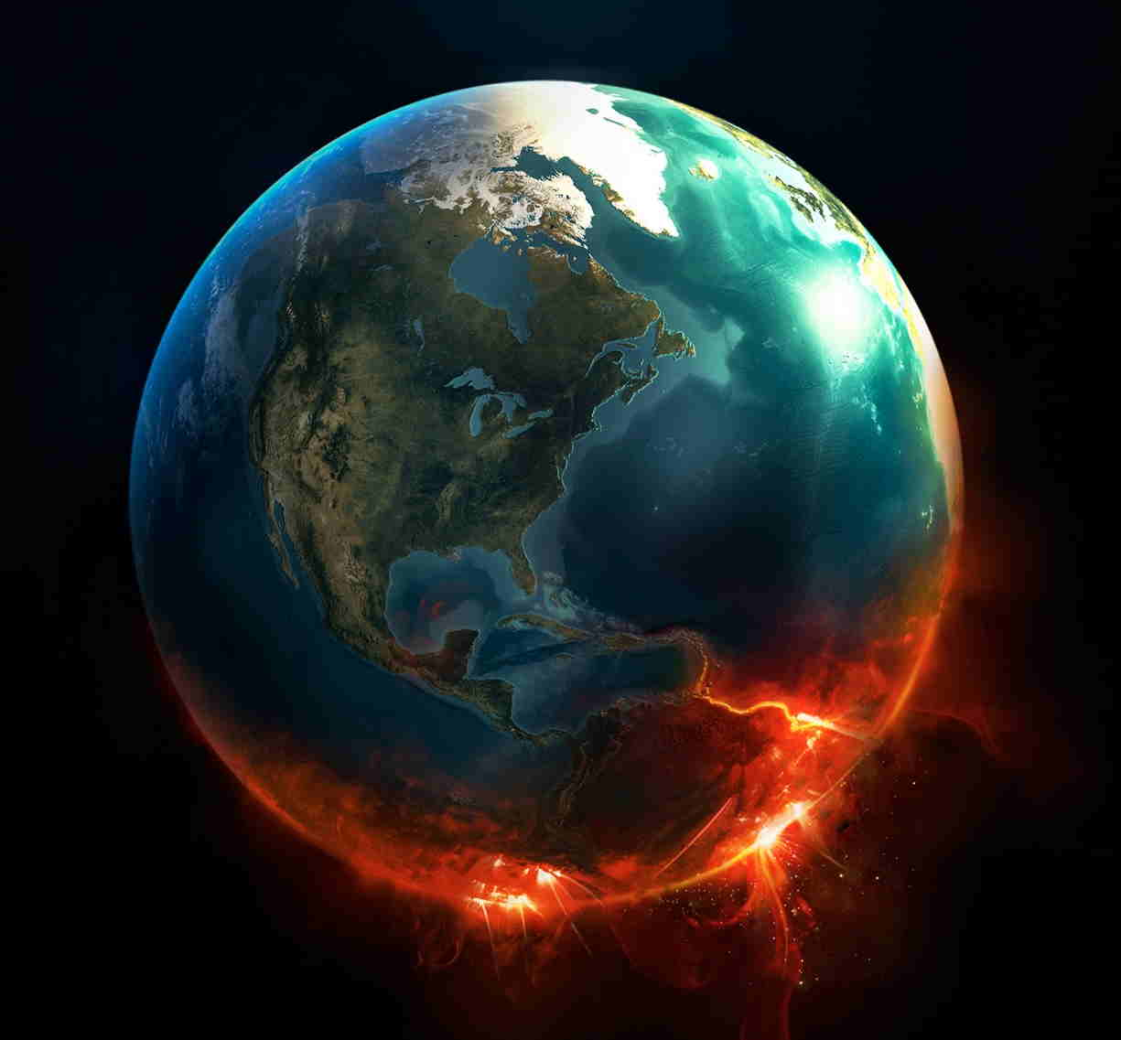
25 And the stars of heaven shall fall, and the powers that are in heaven shall be shaken. I will venture a question: Where will we stand when the elements are so shaken and the impending destruction of the earth is a reality? There is only that same hope in which we have placed our trust from the moment of our salvation - the Lord Jesus Christ. 26 And then shall they see the Son of man coming in the clouds (just as He ascended) with great power and glory. I do not know the terms of salvation of each person reading this devotion, but I do know that many are saved at the moment that they reach the last rung on the ladder to Hell. When there was no other choice, we looked up to the only power that was able to save us just as Peter did when he took his eyes off the Lord and began to sink in the murky waters of the sea upon which he had fixed his gaze. But when he saw the wind boisterous, he was afraid; and beginning to sink, he cried, saying, Lord, save me. (Matt 14:30) Lord, save me" Thus was uttered the shortest prayer in the Bible, and the most urgent.

27 And then shall he send his angels, and shall gather together his elect from the four winds, from the uttermost part of the earth to the uttermost part of heaven. Those who are called and chosen of the Lord (His Elect) shall be gathered by the angels of God into that redeeming bosom that suffered and died at Calvary in our purchase. He it is that is the Great Ark of Salvation from fire just as Noah's Ark was the Ark of Salvation from the waters of the deep.

We now turn to the concluding Parable of the Fig Tree. This Parable is included by our Lord, I believe, to engender hope and confirming faith in the heart of the believer. 28 Now learn a parable of the fig tree; When her branch is yet tender, and putteth forth leaves, ye know that summer is near: 29 So ye in like manner, when ye shall see these things come to pass, know that it is nigh, even at the doors. In the previous verses, our Lord explains the terms of His return. Though we know not the hour or day of His coming, He has not left us without signs. The vineyard keeper does not know the exact time that the buds of the vines will burst forth in bloom, or when the fig tree presents tender branches and green leaves. But he does know that summer is not far away when these signs appear. The same is true of the coming of the Lord. Let us examine what is given us in this parable:
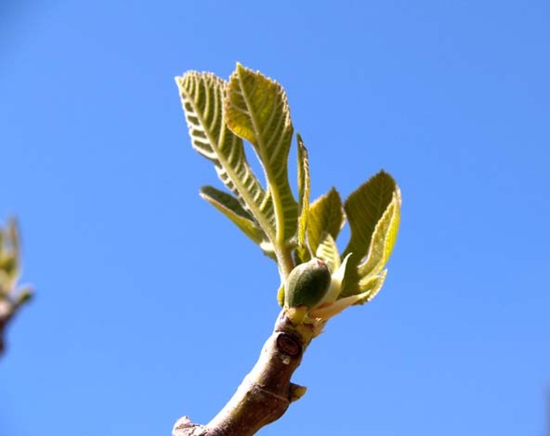
- The signs of the end, like those of the fig tree, are discernible.

- The events will occur rapidly - in one season or generation. 30 Verily I say unto you, that this generation shall not pass, till all these things be done."

- The sequence of events is sure and not reversible. 31 Heaven and earth shall pass away: but my words shall not pass away. Though many so-called 'higher critics' are trying to nullify the Word of God through their cheap and copyrighted new Bible versions, the Word of God still Stands Immutable!

- The exact time or hour is not discernible. 32 But of that day and that hour knoweth no man, no, not the angels which are in heaven, neither the Son, but the Father.

- Just as the keeper of the vineyard or orchard give increased care to the developing fruit of the fig tree, so must the Elect intensify their watchfulness and prayer as the consummation of all things approaches. 33 Take ye heed, watch and pray: for ye know not when the time is.

- The warning is a general one - to All - WATCH! It is true that the totally depraved heart will not watch and wait, those who are chosen in Christ will indeed heed the signs and increase their alertness in watching and praying. 34 For the Son of man is as a man taking a far journey, who left his house, and gave authority to his servants, and to every man his work, and commanded the porter to watch. 35 Watch ye therefore: for ye know not when the master of the house cometh, at even, or at midnight, or at the cockcrowing, or in the morning.

Please disregard the products of yellow journalism that make false and deceitful claims about the impending return of our Lord. I have two books in my library one of which proclaims the Lord's return in 1988, and the other in 1992. Many deceived people sold their household goods, homes, and cars and gave to the false church prior to those dates. Question: If the Lord were, in fact, coming on those dates, why would the church need earthly wealth? Our Lord has departed this earth at His ascension and He has given us to be stewards over His vineyard (Church). We do not know the exact time of His return, so how should we quit ourselves? We should be ready at any moment for His return. We will continue to dress the vines and water the fields. And we will watch ahead to see the clouds unfurl and behold the brightness of His appearing.

36 Lest coming suddenly he find you sleeping." The first three to violate this command were the three apostles in the Garden at Gethsemane - Peter, James, and John - THREE times! And he cometh unto the disciples, and findeth them asleep, and saith unto Peter, What, could ye not watch with me one hour? 41 Watch and pray, that ye enter not into temptation: the spirit indeed is willing, but the flesh is weak. (Matt 26:40-41) Even if we grow weary and are tempted to capitulate to the world, we must keep watch nonetheless.

The final verse reaffirms the general application of the warning: 37 And what I say unto you I say unto all, Watch.

Are you at your watch post?

