Devotion for Wednesday after the Third Sunday in Lent – Blind Bartimaeus, 2 March 2016 Anno Domini

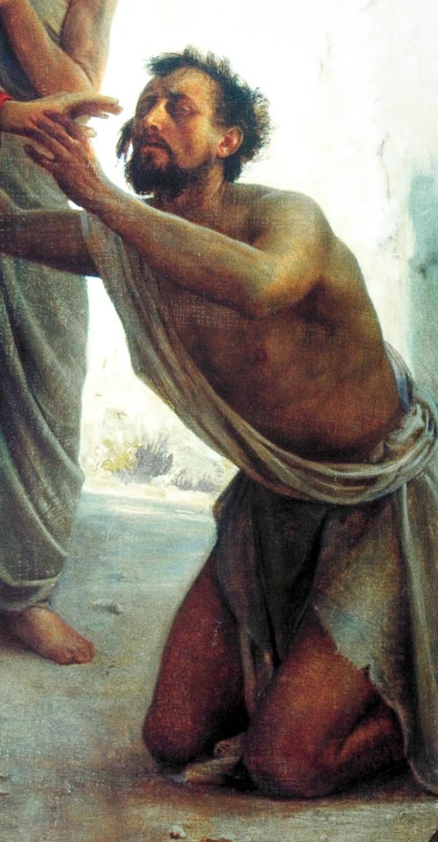

46 And they came to Jericho: and as he went out of Jericho with his disciples and a great number of people, blind Bartimaeus, the son of Timaeus, sat by the highway side begging. 47 And when he heard that it was Jesus of Nazareth, he began to cry out, and say, Jesus, thou Son of David, have mercy on me. 48 And many charged him that he should hold his peace: but he cried the more a great deal, Thou Son of David, have mercy on me. 49 And Jesus stood still, and commanded him to be called. And they call the blind man, saying unto him, Be of good comfort, rise; he calleth thee. 50 And he, casting away his garment, rose, and came to Jesus. 51 And Jesus answered and said unto him, What wilt thou that I should do unto thee? The blind man said unto him, Lord, that I might receive my sight. 52 And Jesus said unto him, Go thy way; thy faith hath made thee whole. And immediately he received his sight, and followed Jesus in the way. (Mark 10:46-52)

Blind Bartimaeus was the son of Timaeus and would remain a dependent son all of his life unless something happened to change his blindness. Blindness is more prevalent in the Middle East than in any other part of the world. Medical science has not been able to discover the reason for this sorrowful condition.

From his early childhood, Bartimaeus had sat in this same place beside the highway begging. It is likely someone had to escort the man to this spot daily, and after, return and collect him for the trip home. In those days, there was no livelihood for the blind; in fact, it was enough of a challenge for a full sighted man to make a living with the labor of his hands. So Bartimaeus had no recourse but to beg.

He often heard comments from passersby that the morning was unusually resplendent with light and cloudless skies. Bartimaeus wondered what it would be like to see a sunrise, to see a cloud, to see a bird – the same which he often heard chirping in the tree branches above him. Oh, and yes! What beauty there must be in the appearance of a bird that could make such wonderful music! He listened with keen ear (the blind are blessed with stronger senses in their other perceptive organs than those who see) to each party that passed by. Some were desponding voices, others angry, and some were kind and cordial – even to a beggar. “Why are some so very kind to me, an unsightly beggar” thought Bartimaeus. And what does blind Bartimaeus look like? If he had vision, might some pretty maiden find him attractive enough to take an interest? But no, it was not to be. Bartimaeus could never hope for the simple joys of a budding rose, or of a family with sons and daughters. He would not have been considered an eligible candidate for marriage.

Of late, there had been a stir of interest among those who passed by in a man named, Jesus! He frequently heard this man’s name mentioned by those passing by. Even scribes and Pharisees traveling up to Jerusalem from Jericho speculated on certain prophecies of such a man as Jesus. The more Bartimaeus heard, the more convinced he became that this Jesus met all of those prophecies uttered of him by those familiar with the Law and Prophets. He heard that Jesus did MIRACLES! He even raised the dead, healed lepers, restored sight, and forgave the most desperate of sinners and adulteresses. Would this not, of necessity, be the Messiah for which Israel had long pined?

This day had something of a magical air to it. It was Spring, just before Passover, and the sun warmed the sidewalks and hearts of men. Bees were humming in the gardens lining the highway, and Bartimaeus, for what reason he did not know, felt that today was a very special day. He had just been deposited at his familiar spot by the wayside by his family members. He had just begun to anticipate whatever gifts the passersby might offer on such a beautiful day – for beauty makes the heart tender. He had just situated himself in as comfortable position as the stony earth would allow when he heard a commotion coming from out of the western gate of Jericho. There was much excited talk, and a host of people in the company. As the crowd grew nearer, the keen ears of Bartimaeus heard much excited talk of a man who had fed 5,000 people with five loaves of bread and two fishes. Then, Bartimaeus heard next that a member of that company had restored sight to a blind man at Bethsaida! How wonderful if Bartimaeus could have shared in that healing at Bethsaida; but he would have had no means of transport to that distant place.

As the throng drew nearer, Bartimaeus heard a man addressed by one of the crowd as Jesus! Jesus! This is the one whom Bartimaeus had heard so much about. Immediately, he knew that it was Jesus who had fed the multitudes and restored sight to the blind man; and he also knew that this Jesus was approaching on the very highway beside which Bartimaeus had sat so many long hours and long days. If Bartimaeus could not travel to see Jesus at Bethsaida, then this same Jesus would come to find Bartimaeus where he sat by the roadside in Jericho! This is very typical of the Lord. When our need is great, and our heart is ready, He will find us! Our Lord had seen Bartimaeus every day of his suffering by the roadside. Jesus knew that He would find Bartimaeus begging there just as He knew that He had an appointment that other time with a woman of Samaria at Jacob’s Well.

As the group approached the very spot where Bartimaeus sat, his heart began to beat with amazing intensity. “This is the hour of my hope, it ever I shall have hope!” he thought. There was obviously a host of men surrounding Jesus. He could hear their warnings for people to make way. But Barimaeus also heard a gentle and kind response from Jesus – sometimes gently rebuking the men with Him to be patient with others on the road. “Such a wonderful Voice filled with kindness and understanding” thought Bartimaeus.

As Bartimaeus is anticipating the close approach of Jesus, our Lord has already known of His lesson of prayer and faith that He intends to teach His accompanying disciples. The disciples took little notice of the poor beggar beside the road until the man, with a loud and unsettling voice, began to call out to Jesus. Bartimaeus knew that this was the decisive moment of his entire life. Would it not be of great benefit if every other poor, blind sinner would not be hushed in calling out to our Lord? “And when he heard that it was Jesus of Nazareth, he began to cry out, and say, Jesus, thou Son of David, have mercy on me.” You will observe that Bartimaeus did not presume to ask for his vision to be restored. He only asked the Lord for mercy, and he KNEW who the Son of David was - for when we have His mercy, we are made whole in every whit. Baritmaeus is praying a simple and forceful prayer. No great and profound words to impress, but “the simple annals of the poor.” (Thomas Gray)

When men ask you your reason for walking with Jesus, do you shush them away? Should we not be joyful when someone appeals to Christ in prayer? But the disciples thought, “How presumptive of this man to call upon the Lord so informally and desperately.” It is often those closest to Christ that keep others away! They tried to keep the man in silence, but that did not work. “And many charged him that he should hold his peace: but he cried the more a great deal,” Baritmaeus was a man of ‘persevering prayer.’ He would not be hushed by those around him. He was addressing the Lord his God! “but he cried the more a great deal, Thou Son of David, have mercy on me.” Do you know that such a plaintive and simple prayer of the suffering will always find mercy in the great heart of Christ? Though Jesus heard Bartimaeus the first time he called out, He wanted the man to persist as an example of such prayer to His disciples.

Though the good Lord must be very busy keeping such as you and me out of trouble, He nevertheless ALWAYS has time to answer sincerely uttered prayer. “And Jesus stood still, and commanded him to be called. And they call the blind man, saying unto him, Be of good comfort, rise; he calleth thee.” When Jesus stands still, something is about to happen. He stood still outside the tomb of Lazarus; He stood still when the woman with an issue of blood touched His garment; and He stood still when He commanded those accusers of the woman taken in adultery who were without sin to cast the first stone – and they melted into the hedges and underbrush. Now He stands still for poor, blind, Bartimaeus knowing full well his need and his blindness since the day he was stricken with it.

Please note the manner in which Bartimaeus came to Christ! “And he, casting away his garment, rose, and came to Jesus.” Bartimaeus was a poor man. All he owned was his garment; but before coming before his Sovereign Lord, Bartimaeus would divest himself of what little earthly possession he had and come to Jesus without a single worldly consideration. Why do we not all follow the example of Bartimaeus? Though he was blind, he came by faith to the sound of Jesus’ Voice to where He stood waiting. He stands waiting for all who have that burning need. Jesus then asked a rhetorical question of Bartimaeus, “What wilt thou that I should do unto thee?” Barimaeus wanted to see! But, allow me to assure you, Bartimaeus could already see the Light of God better than whole and healthy men! “Lord, that I might receive my sight,” Answered Bartimaeus! How wonderful! Since Bartimaeus could see truth in such stark and brilliant colors, he would now be enabled to see the beauty of God’s Creation, and more, in greater starkness. “Go thy way; thy faith hath made thee whole.” Please understand what Jesus tells Bartimaeus! He did not say your faith has restored your sight only, but made you whole in God. In other words, your disease of sin is healed and removed as well. “And immediately he received his sight, and followed Jesus in the way.”

What did Bartimaeus do when Jesus healed his blindness and made him whole?

Did he return to the highway roadside and resume begging? Not at all! He immediately followed Jesus.

Have you done so with such eager dispatch, Friend?

